Wahoo Fitness: Segmentation and Data Insights

The COVID-19 pandemic had a major impact on the personal fitness industry throughout 2020. “Indoor training had been slowly growing but the shift indoors due to lockdowns really tipped the scale,” said John Closs, Head of Business Insights at Wahoo Fitness in Atlanta, Georgia. “It got more people into cycling.” As a result, Wahoo’s sales skyrocketed and by the spring of 2021 they were still catching up on the backlog.

One month before the impact of the coronavirus closed businesses in the United States, Wahoo launched its first watch—the Elemnt Rival GPS smartwatch. The watch catered towards triathletes and included specific features for such athletes. For example, it was the first smartwatch to include touchless transition for triathletes. It was able to identify shifts between swimming, cycling, and running, and automatically switch modes. In the summer of 2021, the Elemnt Rival watch was featured among the best men’s cycling gear of the year.[1]

Closs and the team at Wahoo Fitness (Wahoo) were excited about the potential of this new category. It was the entryway into a market valued at $19 billion in 2020 and projected to grow at a CAGR of 38.6% over the next six years.[2]

The company turned to its roots—data insights. They started with qualitative data surveys to identify customer segments and insights into other market opportunities. “Wahoo still had a relatively low awareness,” Closs said. “Right now, if you don’t consider yourself a cyclist, you are probably not a Wahoo customer.” The team expected to uncover potential sports activity customer segments and decide if Wahoo should engage with cycling hobbyists or leisure cyclists? Or did it make sense to expand on the initial success of the smartwatch and offer more products in the running segment? The option to leverage Wahoo’s expertise in software and add more tracker features might also be attractive.

Wahoo Fitness Story**[3]**

While buying a failing floating water dock business might not have been the career path Chip Hawkins planned on after earning an MBA at Rice University, that was exactly what he did in 2002. Between Hawkins and his partner, they led a turnaround at Wahoo Docks as business grew year over year. The water dock industry heavily relied on new constructions and people buying new houses. With the real estate market crash in 2008, Wahoo Docks went from doubling sales year over year to flat growth.

With the slowdown in the water dock business, Hawkins found himself with more free time. His wife convinced him to sign up for a duathlon. Although a water sports enthusiast, Hawkins had not done much cardio exercise up to this point and had to quit midway through the first race. That experience motivated Hawkins to get serious about physical fitness. He bought better equipment and started training.

Spending time training, Hawkins eventually got into triathlons. His engineering background instilled the importance of data and validation. Cyclists mainly relied on five different data categories. Distance and elevation helped cyclists understand how far they pedaled and at what steepness (called gradient). Speed informed cyclists how fast they moved (and not a good indication of effort since riding downhill was easier than riding uphill). Heart rate helped cyclists understand how hard their body was working. And power was perhaps the most unique, yet important, data for cyclists. Power allowed cyclists to measure their effort in a reliable and consistent way. Measured in watts, even over widely different road gradients and wind conditions, the amount of energy used over time was key to training. Combining the five sets of data, a cyclist was able to know their distance, power, speed, elevation, and heart rate at any exact point in time.

While training, Hawkins relied on a Garmin bike computer for distance and speed data but had to use another device for power data. Merging data from one device to another was a challenge. Additionally, it was a hassle to upload data into his computer and impossible to upload it to his smartphone. Hawkins knew he could build a better product. He started building an adapter that allowed a sensor to connect to a smartphone. The co-owner of Wahoo Docks became the founder of Wahoo Fitness in November 2009.

Wahoo’s First Success

Running and cycling apps were already prominent in app stores and widely used by 2010 (e.g., Runkeeper, Mapmyride, Strava). Since one of the most common requests from app customers was the ability to track and upload heart rate data to their phones, Hawkins built a wireless Ant+[4] system key adapter that would connect heart rate and other wireless health and fitness devices to a smartphone. In search of a partnership on the new Ant+ adapter technology, Wahoo reached out to contacts at Apple. Although uninterested, a vague hint was shared by Apple that a new technology had just been released in one of their new devices that might be of interest. Hawkins browsed online and discovered the newly released MacBook Air included Bluetooth Low Energy (BLE) technology.[5] The BLE technology was not advertised at all by Apple. If Apple implemented the BLE technology in the iPhone it would completely disrupt Wahoo’s core product which used the Ant+ system. Hawkins and his team decided to bet that the next iPhone, the iPhone 4S, would come with BLE technology enabled. The team at Wahoo immediately started researching and developing a new BLE system, which included running around the parking lot with a MacBook Air strapped to their back!

When Apple released the iPhone 4S in October 2011, everyone at Wahoo was ecstatic to see that the new phone did indeed have BLE technology. Within a couple of months, Wahoo launched a BLE enabled heart rate monitor and for one and a half years was the only BLE enabled technology in the market. Apple started selling Wahoo’s products in the Apple store and all fitness apps started using Wahoo’s API. Wahoo’s sales took off.

Wahoo Growth

As Hawkins’ interest in triathlons grew, he spent more time training inside and bought a CompuTrainer indoor bike trainer.[6] CompuTrainer had been making indoor cycling training equipment since the 1970s. Hawkins’ indoor cycling experience was like his introduction to riding outdoors. The CompuTrainer system was clunky and difficult to use. The difference was there already were several players in the smart indoor trainer industry, but Hawkins was not discouraged. He recalled one of his MBA professors saying that having other players present in the market was a good thing. It showed that there was a real and viable business to be made.

Hawkins and his team realized that most companies in the indoor trainer industry, such as Tacx, made their equipment using a closed system. That meant their proprietary software could only be used with their trainer. Wahoo saw an opportunity to build an open system. In 2013, Wahoo launched the Wahoo Kickr as their first smart indoor trainer.[7] The Kickr came with an open API and Wahoo encouraged people to develop software around it. Shortly thereafter, numerous computer software and apps started popping up. Some would become huge hits, for example Zwift and TrainerRoad. This decision to offer an open system translated into Wahoo partnering with several new software companies. “As a company we are driven to innovate on fitness technology and leverage workout data so athletes can consistently improve the way they train and perform,” Hawkins said.[8] Customers loved it and the Wahoo Kickr became the market leader. Wahoo built several different products and accessories around the Kickr brand winning awards for top design. The Wahoo Kickr brand continued to hold the top position in the smart trainer market in 2021. In addition to the Kickr brand, Wahoo developed a successful outdoor cycling product portfolio (see **Exhibit 1**).

In 2018, Wahoo received funding from investment firm Norwest Equity Partners[9] and started to look for acquisitions to grow its brand. The following year, Wahoo acquired pedal manufacturer Speedplay and software company Sufferfest. Speedplay had a long history of product innovation and grew to become one of the leading high-performance pedals. The business had a similar mission to Wahoo’s, improving the cyclist experience, and fit in well with Wahoo’s product portfolio. Sufferfest was a bit different. Sufferfest was a software product that competed directly with Zwift and TrainerRoad, some of Wahoo’s long-term partners. At the time, Zwift announced that it would start to build its own hardware products including indoor trainers. “We think that Sufferfest is different from everything that is out there,” Closs said. “In uniquely blends content and structured training workouts that is different from anything else in the industry.”

By the spring of 2021, Wahoo was a leading brand in cycling employing over 300 people. “Our business was a 50/50 split between US and international,” Closs said. “Growth is especially coming out of Europe.” To that end, worldwide, Wahoo sponsored some of the biggest names in the industry, including Peter Sagan, Mathieu van der Poel, Julian Alaphilippe, and Jan Frodeno. Additionally, Wahoo sponsored teams including the Ineos Grenadiers, Quick-Step, Bora-Hangrove and Alpecin-Fenix.[10] Athletes using Wahoo products had won all major races in cycling and triathlon, including the Tour de France, Giro de Italia, Ironman Kona World Championship, and the Olympics.[11] See **Exhibit 2** for photos.

Wahoo Fitness Product Overview

The company he founded had come a long way from where Hawkins started. From the adapter that launched Wahoo to the move into wearable products with the smartwatch, Hawkins had been intentional about growth and new products. Each of Wahoo’s products offerings could be categorized as hardware or software. Wahoo started as a hardware company and the majority of its revenue still came from the hardware fleet of products. These included three different categories: indoor cycling, outdoor cycling, and multi-sport.

*Indoor Cycling*: Wahoo’s indoor products provided cyclists the ability to control and simulate outdoor conditions, providing a “real ride” experience that navigated between virtual and reality. These products were often used to train at home. Pro cyclists also used these products to warm up and cool down before and after races.

*Outdoor Cycling*: Wahoo’s outdoor products were aimed to improve the cyclist experience while riding outdoors. Its GPS computers tracked and recorded all available data, additionally it allowed for on-device navigation to get the cyclist to where they wanted to go. Wahoo’s proprietary pedal system improved cyclist performance and safety.

*Multi-Sport*: Wahoo’s multi-sport products allowed customers to track and record data in a variety of different sports. The Elemnt Rival GPS watch focused on triathletes and included specific features for runners, swimmers, and cyclists.

On the software side, Wahoo offered Wahoo Fitness phone apps, and acquired Sufferfest’s training platform (see **Exhibit 3** for details Wahoo’s software products). “We need to increase revenue from our software products,” Closs said. “I would like to push more hardware customers to software subscriptions and increase customer lifetime value.” Closs didn’t see software as a “winner take all” market. “I don’t see why you can’t subscribe to Sufferfest and Zwift,” he said.

To purchase Wahoo products, customers could order directly from Wahoo’s website or through international distributors/dealers/retailers in 49 cities worldwide.[12] In the US alone, Wahoo products were available in 214 retailers.[13] “Wahoo pursues a multi-level sales concept in Europe, working partly with distributors,” Kevin Apt, head of sales said. “But in many areas there is reliance on a direct dealer approach.”[14] Wahoo used a global network of warehouses to distribute its products to more than 97 countries.[15]

Competitive Landscape

Wahoo Fitness found itself in a quickly evolving competitive landscape that provided some unique challenges—some formerly exclusively partners evolved to become competitors. Emerging technologies such as wearable fitness devices and augmented reality had changed consumers’ experiences. “We don’t view Fitbit, Apple watches, and even Peloton to be much of a competitor,” Closs said. “Garmin’s acquisition of Tacx—our largest competitor in indoor equipment—made it our number one competitor.”

**Garmin:** offered products across a variety of sports categories, such as cycling, swimming, and hiking. While Garmin traditionally focused on wearables, accessories, and GPS tools, the 2019 acquisition of Tacx, a manufacturer of indoor cycling trainers and other cycling specialty equipment, moved it into the fitness segment. With this acquisition Garmin moved directly into Wahoo’s llargest product category, and was now competing head-to-head in all categories. Garmin had strong capabilities and strategic position with data on endurance athletes to step into Wahoo’s space with confidence.

**Zwift:** wasone of Wahoo’s major partners, it was a software company that provided an app for indoor cycling and running. With the app, users could explore or compete in races, across the digital world of Watopia or within a rotating collection of cities and countryside worldwide. Zwift had not released data on its number of users, but estimates were around 20,000 individual users visited its platform each day and the 2020 Tour de Zwift event saw almost 120,000 participants.[16] The app connected to a variety of hardware, embracing a similar open access strategy to Wahoo, and Wahoo products could be purchased on the Zwift website. “If consumers use Zwift but have a whole Wahoo hardware setup,” Closs said. “We don’t get that data—we give customers the option to share their data with whoever they want.” In September 2020, Zwift raised $450 million at least in part to finance the creation of its own hardware offerings[17] and employed more than 500 people.[18]

**Peloton:** an exercise equipment company founded in 2013 in the US. Peloton has seen considerable growth, especially through the release of its stationary bicycle. The company reduced its bike price $350 in 2020 and revenue from that segment increased 169.7% by June 2021.[19] Peloton had over 6,500 employees.[20] In addition to the hardware, the company had its own community software that distributed content such as instructional videos and live exercises. Subscription revenues jumped from $80.3 million in 2018 to $363.7 million in 2020.[21] While the Peloton focus on hardware and content were similar to Wahoo, its targeted market segment was considerably different.

**Apple, Samsung, and Google:** while these tech companies may not seem like a competitor at first glance, they did make subtle moves into the endurance sport market. Apple’s introduction of the Apple watch in 2015 entered the firm into the wearables market, and it quickly became the top wearables seller. While the watch wasn’t marketed specifically for athletes, Apple had been developing features to make it more appealing for athletic activities. With the ability to track real-time workout data, the built-in workout tracks, and the different exercise routines for swimming, running, and cycling, Apple positioned itself as a real competitor in the space.

**Other Players:** there were other smaller players in the field that competed on several different angles. Polar 1,200 employees)[22], Suunto (400 employees),[23] and Coros all played in the crowded GPS sport watch category. With approximately 500 employees,[24] Whoop offered a wearable product and accompanying app focused on a more wholistic health profile including sleep and stress. There were also platforms such as Strava, with over 275 employees,[25] that created a social media space for exercise enthusiasts. “Strava is a super important partner and is the most widely used platform by our customers,” Closs said. The fitness technology space was complex and crowded.

The COVID-19 pandemic did present Wahoo with an interesting competitive twist. Wahoo was better able to take advantage of a surge in demand than its competitors, as the strong manufacturing relationships it already had in place enabled it to scale up faster than their competition. This led to a market share increase for indoor trainers.

**Wahoo Expansion Options**

By focusing on the “tip of the spear” cyclist, Wahoo had created a dominant brand within the “hardcore” cycling segment. “Wahoo doubled down on what we do well—avid cyclists and endurance athletes,” Closs said. “For us it is all about the ecosystem of our products and how they work together.” Yet growth potential within this niche segment was limited. With the launch of the Elemnt Rival watch, Wahoo officially expanded into the triathlete’s segment. This was a logical next step given the overlap of triathlon and cycling. Wahoo already had many triathletes using their cycling products. Thinking about expansion, Closs and his team looked at three areas that could be a good fit for Wahoo:

**Spinning:**Led by Peloton, there had been a massive increase in the popularity of taking spinning classes from home. Wahoo had the technological expertise in developing indoor cycling equipment and it could easily develop products catered to that market. There was, however, a big difference between Wahoo and Peloton’s customers. Peloton customers were more focused on general fitness, while Wahoo customers were preparing for their next race. Moreover, Wahoo lacked the media content that Peloton had created with its professional instructors. Spinning presented an opportunity to reach a larger audience (expected to grow to from $508.9 million to $623.8 million in 2026),[26] but it could also damage the branding Wahoo had successfully built around the competitive cyclist.

**Running:** The Wahoo Elemnt Rival watch presented the opportunity to expand into running, a much larger segment than cycling. The Rival watch already possessed the basic technology tools that runners needed. The drawback was many runners didn’t know about the Wahoo brand. Additionally, running was a segment with fierce competition and many established players such as Garmin, Apple, and Fitbit. Could Wahoo differentiate from competitors? Would using the same “tip of the spear” strategy work to develop new products and features for runners?

**Existing customers:** Another growth strategy would be tocontinue to focus on its existing customers of passionate cyclists and triathletes but with new products and services. This could include entering new hardware product categories, expanding existing hardware categories or developing new software content, features and metrics to grow recurring software sales. Wahoo had the engineering, hardware design and software development expertise to create new hardware. However, developing new content and software features would require building out several capabilities within the company. For example, training software program recommendations on The Sufferfest could be further personalized based on customer training data but would require Wahoo to invest in data science capabilities for algorithm development. In terms of hardware, new versions of watches, heart rate monitors and other GPS product could be developed specifically for triathletes. Industrywide trends pointed to new tracking devices in the form of bracelets, rings, or glasses. Some in the industry were exploring clothing items such as the smart shirt, shoes, socks, hats, or pants that can track athlete performance.[27]

**Consumer Survey**

To keep pace with competitors as well as grow beyond, Wahoo had several considerations. Customers wanted ease of use devices, innovation, and functionality. Additionally, “we want to create a more seamless experience,” Closs said. Wahoo collected data from product, website, and social media. “We leverage data on our apps to better understand our customers and to create better products,” Closs said. “And do better cross-selling.” As they considered growth, Wahoo decided to conduct a survey to gather data and ultimately improve their strategy, consumer targeting, marketing plans, and innovation pipeline. Closs and his team hoped to use insights from the survey to assist Wahoo in their decision of where to expand next. More specifically, objectives of the research included:

* Understand sizing, targeting, and profiles of the different consumer types that “live an active lifestyle”
* Define consumer types that have highest potential for Wahoo
* Understand behaviors, product usage, and attitudes of existing and potential Wahoo consumer types

The survey used two different data sources. The first was 250 Wahoo users identified via the Wahoo owners mailing list. The second was 400 random people identified by a third-party consulting company. The survey participants had to fit the following criteria:

* Perform at least some sport activity regularly each week
* Spend at least $100 on sports in last 12 months
* Age: 18-65 years old
* Gender: Maximum 300 participants either gender
* Cyclist Quota: 100 respondents (few times a month)
* Runner Quota: 100 respondents (1 – 4 hours per week)
* Triathletes Quota: 50 respondents (few times a month)
* Indoor Bike Training Quota: 100 respondents

The survey included two sets of questions based on the customers attitudes and behaviors as shown in **Exhibit 4**. Additionally, the survey indicated several facts about the customer such as gender, age, sports practiced, and equipment used during activity. See **Exhibit 5** for the segmentation process.

**Where to Go from Here?**

While the COVID-19 pandemic was a tragedy that impacted humans worldwide, for the fitness industry, there was a small silver lining. The lockdowns and isolation drove an increased interest in cycling, opened people up to the benefits of exercising at home, and heightened the importance of mental and physical health for many individuals. More customers expected in-depth tracking data, encompassing more components of their lives, and were asking for more interactive and social fitness experiences. The shift in industry dynamics highlighted opportunities and attracted capital allowing many companies to pursue expansion through product offerings. Moreover, it opened doors for new entrants.

Wahoo was in the same position. Many of the pandemic-induced changes drove success in the short-term for Wahoo. It also brought into question where they should expand next. Should they move beyond “hardcore” cyclists and triathletes to capture more of the mainstream fitness-conscious Peloton users? Should Wahoo extend into the running segment with its new GPS watch? Or should new software features and hardware products be launched to target existing customers? Or something else? Closs and his team expected to analyze the survey data and use the insights from the segmentation process as a starting point to better understand who consumers were, or might be, as they tailored strategies around product offerings.

Exhibit 1

Wahoo Fitness: Segmentation and Data Insights

Wahoo Hardware Product Portfolio March 2021

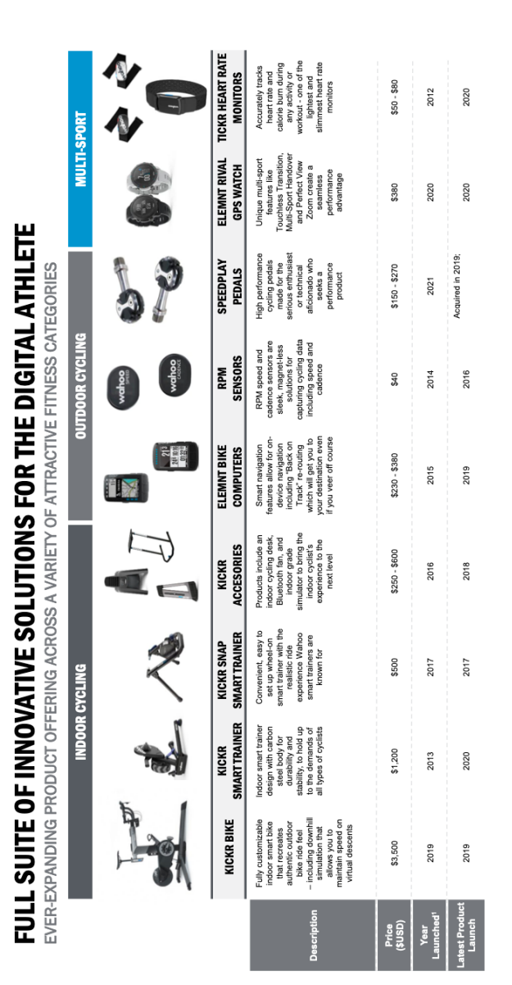

Source: Company provided. Used with permission.

Exhibit 2

Wahoo Fitness: Segmentation and Data Insights

Ineos Pro Cyclist, Michał Kwiatkowski, warms up on Wahoo Kickr[28]

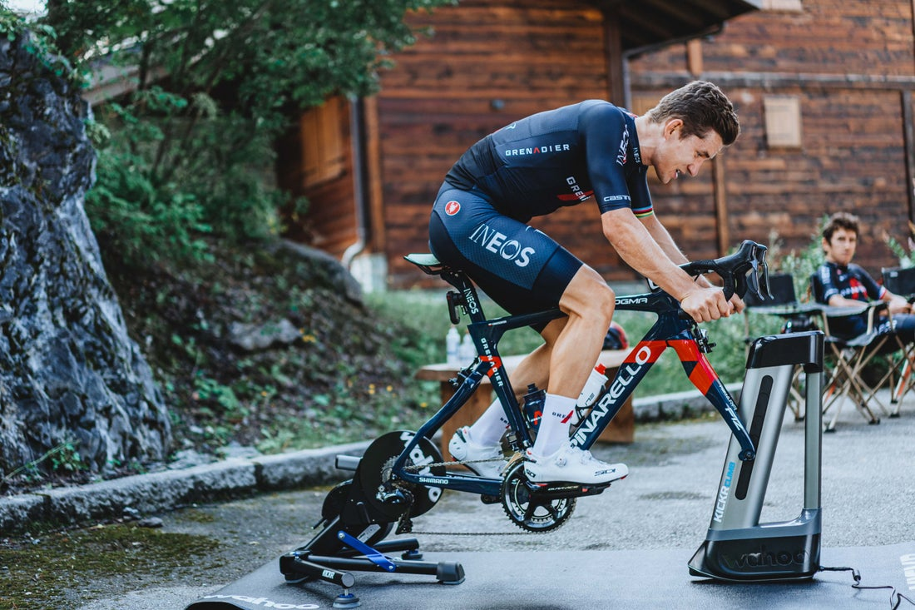

Exhibit 3

Wahoo Fitness: Segmentation and Data Insights

Wahoo Software Product Portfolio

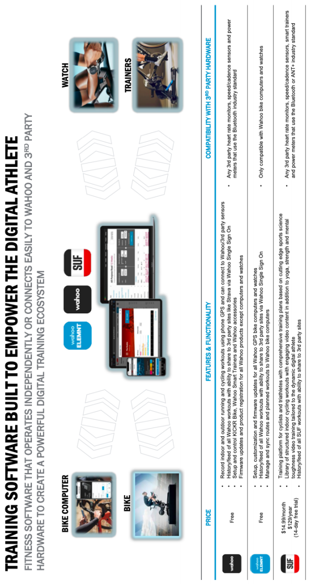

Source: Company provided. Used with permission.

Exhibit 4

Wahoo Fitness: Segmentation and Data Insights

Wahoo’s Customer Survey Attitude and Behaviors Questions

1. For each pair of statements below, please indicate which statement you agree with most

|  |  |  |  |  |  |  |  |  |  |  |  |  |  |  |  |  |  |
| --- | --- | --- | --- | --- | --- | --- | --- | --- | --- | --- | --- | --- | --- | --- | --- | --- | --- |
|  | |  | | |  | | | | |  | | |  |  | | |  |
|  | | | | Agree Much More | | | Agree Somewhat More | | Agree Somewhat More | | Agree Much More |  | | |  | | | |
| a. | Price is an important factor when I buy sports equipment | | *1* | | | *2* | | *3* | | | *4* | I buy the highest quality sports equipment | | | |  | | | |
| b. | I gather information from friends / family before I buy | | *1* | | | *2* | | *3* | | | *4* | I do research online before I buy | | | |  | | | |
| c. | I look forward to my sport activity / training | | *1* | | | *2* | | *3* | | | *4* | I train because I feel an obligation to do so | | | |  | | | |
| d. | I manage my nutrition / diet carefully | | *1* | | | *2* | | *3* | | | *4* | I am active so that I can eat any food I want | | | |  | | | |
| e. | Improving my performance is important to me | | *1* | | | *2* | | *3* | | | *4* | Enjoying my activity is important to me | | | |  | | | |
| f | Spending time with friends makes my sport activity more fun | | *1* | | | *2* | | *3* | | | *4* | Sports are a way for me to get away from stress | | | |  | | | |
| g | I like trying new activities | | *1* | | | *2* | | *3* | | | *4* | I want to be the best at one activity | | | |  | | | |
| h | I work to pay for my passions | | *1* | | | *2* | | *3* | | | *4* | Professional success is important to me | | | |  | | | |
| i | I will buy equipment / accessories when I see a good discount | | *1* | | | *2* | | *3* | | | *4* | I shop less so I can save to buy higher quality equipment | | | |  | | | |
| j | I don’t have enough time for my sport activity / training | | *1* | | | *2* | | *3* | | | *4* | I make time to pursue my sport activity / training | | | |  | | | |
| k | I enjoy time relaxing away from my sport activity / training | | *1* | | | *2* | | *3* | | | *4* | I like to be active most the time | | | |  | | | |

1. How much do you agree or disagree with the following statements? (Select one answer in each row)

5-PT SCALE WHERE 1=STRONGLY DISAGREE, 3= NEITHER AGREE NOR DISAGREE, AND 5 = STRONGLY AGREE

* 1. I manage my recovery time and sleep to improve sport performance
  2. I know a lot about my sporting equipment
  3. I maintain my own sporting equipment
  4. I follow a structured training plan to improve my performance
  5. I track and use data to measure my performance
  6. Most of my friends also participate in my sport activity
  7. I set specific performance goals for my weekly activity
  8. I spend time following or reading about my sport when I’m not doing it
  9. I enjoy watching professional events for my sport on TV
  10. I enjoy going to events to watch my sport live
  11. I prefer to work out or train indoors vs outside
  12. I am competitive in everything I do

Source: Company provided. Used with permission.

Exhibit 5

Wahoo Fitness: Segmentation and Data Insights

The Segmentation Process



Source: case author

1. Josh Patterson, “The Best Men’s Cycling Gear of 2021”, *Outside Magazine*, May 10, 2021, [The Best Men’s Cycling Gear of 2021 | Outside Online](https://www.outsideonline.com/outdoor-gear/bikes-and-biking/best-mens-cycling-gear-2021/) (accessed Aug. 6, 2021).
2. “Outdoor Sports GPS Device Market Size 2021 with CAGR of 38.6%, Top Growth Companies: Garmin, SUUNTO, Adidas, and, End-User, SWOT Analysis in Industry 2026” Market Watch Press Release, June 16, 2021.
3. The material in this section draws heavily from two podcast interviews with Chip Hawkins. *Home Roads Podcast*, episode “Chip Hawkins north of Atlanta, Georgia” [‎Home Roads: Chip Hawkins north of Atlanta, Georgia on Apple Podcasts](https://podcasts.apple.com/us/podcast/chip-hawkins-north-of-atlanta-georgia/id1390742483?i=1000443879801) (accessed Aug. 8, 2021) and Triathlon Taren Podcast, episode “Wahoo Fitness Founder Chip Hawkins on: Starting Businesses, The Future of Bike Tech, and Taking Risks Ep.008.” [Triathlon Taren Podcast - Wahoo Fitness Founder Chip Hawkins on: Starting Businesses, The Future of Bike Tech, and Taking Risks Ep.008 - Triathlon Taren Podcast (google.com)](https://podcasts.google.com/feed/aHR0cHM6Ly90cmlhdGhsb250YXJlbnBvZGNhc3QubGlic3luLmNvbS9yc3M/episode/aHR0cDovL3RyaWF0aGxvbnRhcmVuLmNvbS8_cD05OTE?sa=X&ved=2ahUKEwjQsdrL2t7wAhURioQIHRy0CEMQkfYCegQIARAF), (accessed Aug. 8, 2021).
4. Ant+ is a network protocol like Bluetooth but with more flexible ways for network devices to connect to each other. See [Help | ANT Wireless Networks | Garmin Developers](https://developer.garmin.com/ant-program/help/) for more.
5. BLE wireless required less energy than Bluetooth and other network protocols.
6. Outdoor bicycles are attached to these devices enabling riders to train indoors.
7. An indoor trainer is a product that connects and turns your regular bicycle into a stationary bicycle. A smart indoor trainer will allow the cyclist to connect the trainer to a computer and control the resistance of their pedaling. This allows for a software to control your bicycle and give the cyclist a real simulation of outdoor riding. For example, as you go uphill within the virtual world, it becomes harder for you to pedal at home.
8. Brian Staff, “Wahoo Fitness, After Growing 235% in Three Years, Lands on the Deloitte Fast 500 List,” *Bicycle Retailer,* December 12, 2017, [Wahoo Fitness, after growing 235% in three years, lands on the Deloitte Fast 500 list | Bicycle Retailer and Industry News](https://www.bicycleretailer.com/industry-news/2017/12/12/wahoo-fitness-after-growing-235-three-years-lands-deloitte-fast-500-list#.YTJZSfeSmUl) (accessed Sept. 3, 2021).
9. John McNulty, “NEP Invests in Wahoo Fitness”, *Private Equity Professional,* July 26, 2018, <https://peprofessional.com/2018/07/nep-invests-wahoo-fitness/> (accessed Jun. 13, 2021).
10. Fun fact , UVA student and pro cyclist Edward Anderson rides for Alpecin-Fenix.
11. See [Wahoo Sponsored Teams & Athletes | Wahoo Fitness](https://www.wahoofitness.com/athletes) for more.
12. Wahoo, “International Retailers,” [International Retailers and Distributors | Wahoo Fitness](https://www.wahoofitness.com/international-dealers) (accessed Sept 7, 2021).
13. Wahoo, “Store Locator,” [Find a KICKR Experience Station Near You | Wahoo Fitness](https://www.wahoofitness.com/store-locator) (accessed Sept. 7, 2021).
14. Gary, “Wahoo Fitness Confirms Dedicated Territory Manager in Southeast Europe,” *Endutance.biz,* March 19, 2020, [Wahoo Fitness confirms dedicated Territory Manager in Southeast Europe - endurance.biz](https://endurance.biz/2020/industry-news/wahoo-fitness-confirms-dedicated-territory-manager-in-southeast-europe/) (accessed Sept. 9, 2021).
15. Wahoo, “Shipping & Delivery,” [Shipping and Delivery Info | Wahoo Fitness](https://www.wahoofitness.com/shipping-and-delivery) (accessed Sept. 7, 2021).
16. Gary, “Zwift by numbers: 120K take on the 2020 Tour de Zwift,” *Endurance.biz*, February 21, 2020, <https://endurance.biz/2020/industry-news/zwift-by-numbers-120k-take-on-the-2020-tour-de-zwift/> (accessed Jun. 13, 2021)
17. “Zwift Plans to Offer Its Own Hardware Following $450 Million Investment | Bicycle Retailer and Industry News,” *Bicycle Retailer and Industry News*, September 16, 2020, <https://www.bicycleretailer.com/industry-news/2020/09/16/zwift-plans-offer-its-own-indoor-bike-following-450-million-investment#.YEZisdxOlEY> (accessed Jun. 13, 2021)
18. Nat Rubio-Licht, “Setting The Pace: Silicon Beach Players Are Paving the Way For Post-Pandemic Workplaces,” *Los Angeles Business Journal,* June 28, 2021, <https://labusinessjournal.com/news/2021/jun/28/tech-companies-pave-way-post-pandemic-worksplaces/> (accessed Sept. 30, 2021).
19. Peloton Form 10-K, 2021.
20. Peloton Form 10-K, 2021.
21. “Annual Subscription Revenue of Peloton Worldwide from 2017-2020,” *Statista,* <https://www.statista.com/statistics/1203061/peloton-subscription-revenue/> (accessed Sept. 9, 2021). 
22. Polar, “Who We Are,” <https://www.polar.com/en/about_polar/who_we_are> (accessed Sept. 30, 2021).
23. “Join the Adventure at Suunto,” <https://www.suunto.com/en-us/About-Suunto/careers/> (accessed Sept. 30, 2021).
24. Andrei Chirileasa, “US Startup with Romanian Co-founder Reaches USD 3.6 bln Valuation,” *Romoania-Insider.com* August 31, 2021 (accessed Sept. 30, 2021).
25. “Strava Accelerates Growth with Opening of New Office in Dublin, Ireland,” *PRNewswire,* July 21, 2021, <https://www.prnewswire.com/news-releases/strava-accelerates-growth-with-opening-of-new-office-in-dublin-ireland-301338062.html> (accessed Sept. 30, 2021).
26. “Global Exercise Bike Market: By Product Type,” *EMR,*  [Exercise Bike Market Size, Share, Analysis, Report 2021-2026 (expertmarketresearch.com)](https://www.expertmarketresearch.com/reports/exercise-bike-market) (accessed Sept. 10, 2021).
27. For examples of these products see Ambiotex, Owlet, and Sensoria . Mind Commerce, “Connected Wearable Device Market in Healthcare, Wellness, and Fitness Market Outlook and Forecasts 2021-20218,” January 2021, [Connected Wearable Device Market in Healthcare, Wellness, and Fitness by Device Type, Use Case, and Application 2021-2026 (researchandmarkets.com)](https://www.researchandmarkets.com/reports/5232537/connected-wearable-device-market-in-healthcare) (accessed Sept. 7, 2021).
28. Source: Wahoo Media Kit. Used with permission.